Infrastructure (5 to 11 men weeks)

Upgrade to .NET 3.0 (1 man week)

Applying WCF (4 to 10 men weeks)

Refactoring entities to conform to WCF (1 man week)

Refactoring services (Interfaces & Implementations) to conform to WCF (1 man week)

Refactoring web services & proxies to conform to WCF (2 to 8 men weeks)

Workflow (16 to 28 men weeks)

Requirements (2 men weeks)

Implement WF infrastructure, work flow management services and data tables (2 men weeks)

Refactoring existing use cases to support work flows (6 to 12 men weeks)

Implement WF for new use cases (6 to 12 men weeks)

Use Cases
How many use cases?
For each use case, it will take around 8 men weeks
Requirements (1 men week)
Analysis & Design (1 men week)
Refactoring (1 to 3 men weeks)
Entities & Test Data & UI & UIP (2 men weeks)
Service & Dao & Database (2 men weeks)
Integration & System Tests (1 men week)

Job Incidents

Coided Tubing

Fracturing

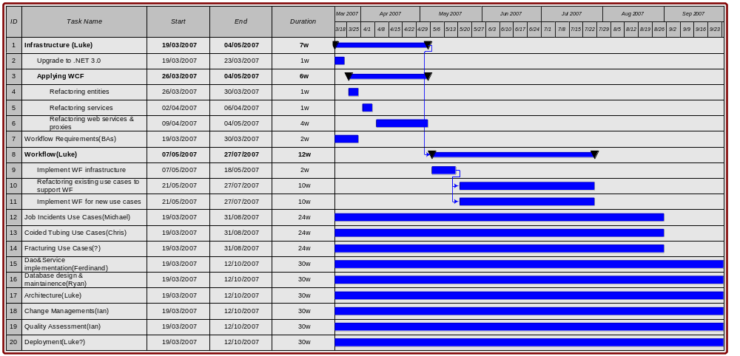

Infrastructure must happen before Workflow.

Use Cases can be done concurrently.

Implement Workflows (2.3 & 2.4) can be done concurrently but must after task Implement WF infrastructure (2.2).

